
Bournemouth Arrow CC
Good Friday 10 Mile Time Trial

Promoted for and on behalf of Cycling Time Trials under their Rules and Regulations

Course: P311 Event Secretary: Peter Fairbank
Date: Friday 7th April 2023 11 Moors Close
First Rider: 9.01am Christchurch Timekeepers: Dorset BH23 6AL
Start Mr Peter Perrin
Finish Mr Julian James petercyclismimey@outlook.com
Recorder Mr Steve Moss Mobile: 07941 052341

The event headquarters are:

Greyfriars Community Centre 44 Christchurch Road BH24 1DW

Look for the Arrow teardrop banners
There is a small car park at the Centre and a large Pay and Display car park just off the A31 within 500 metres of the centre. More parking information will be sent to you soon.
There is no parking space at the finish.

Route from HQ to the Start:
Right out of HQ along Christchurch Road, turn left at the Lidl roundabout approx 500m to the south.
Route from Finish to HQ:
Continue north along Christchurch Road for 1km.

NUMBERS & SIGNON WILL BE AT THE EVENT HEADQUARTERS, NOT AT THE START.

IN THE INTERESTS OF YOUR OWN SAFETY,
Cycling Time Trials and the event promoters strongly advise you to wear a HARD SHELL HELMET that meets an internationally accepted safety standard.

In accordance with Regulation 15, ALL JUNIOR competitors must wear Protective Hard Shell Helmets.

It is mandatory that a WORKING FRONT and REAR LIGHT, either flashing or constant, is fitted
to the machine in a position visible to following road users and is active while the machine is in use.
P311 Course Description:
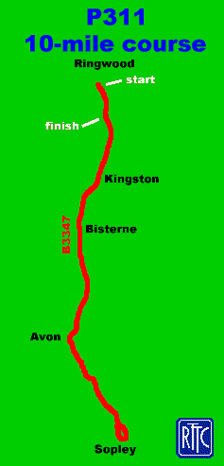
START at first lamp post in Wellworthy Road, proceed west for 30m to new roundabout at Ringwood on B3347.(SU153044)
Turn left onto Christchurch Road, proceed south via Bisterne and Avon to Sopley one-way system. (5.2m)
Turn right over bridge at the Woolpack and retrace to Ringwood via Avon and Bisterne to
FINISH at drain 10 yds south of junction with Hampshire Hatches Lane at Moortown Green. (SU153038)

Route from HQ to the Start:
Right out of HQ along Christchurch Road, turn left at the Lidl roundabout approx. 500m to the south.
Route from Finish to HQ:
Continue north along Christchurch Road 1km to the north.

SAFETY INSTRUCTIONS
Riders must:
- Not make U turns in the vicinity of the Start or Finish
- Not warm up on the Course.
- Not stop at the Finish but continue to the event Headquarters.
- Not cut the corner at Sopley one-way system on 1st right turn as the road is two-way at this point.
- Take Extra Care:-
    - From start to Moortown Lane – busy with houses and side roads, David Lloyd entrance on right, garage on left, finish on right.
    - Avon Tyrrell Farm - sharp bend with possible gravel.
    - Avon Causeway junction- beware of traffic stopping to turn right or emerging onto course.
    - At the Sopley turn – the road surface is poor over the bridge, we recommend those on TT bikes feather the brakes while you make this turn.

Any rider observed riding in a manner which may jeopardise his or her own safety, the safety of others and the future of the Sport, will be disqualified and reported to the South District Council of Cycling Time Trials.
PRIZES (One prize per rider.)
Solo bikes - male
First £50.00
Second £25.00
Third £15.00
Solo bikes – female
First £50.00
Second £25.00

Road bikes – male
First £50.00
Second £25.00
Third £15.00
Road bikes – female
First £50.00
Second £25.00
The solo rider with the fastest time will keep the Barrie Watkinson memorial trophy for a year.

